

Bachelor of Computer Applications (BCA) Programme

Minor Project Report

BCA Sem V

AY 2023-24

*Project Title: Virtuous Diam*

*by*

|  |  |  |
| --- | --- | --- |
| Exam No. | Roll No. | Name of Student |
| 5897 | 765 | Parikh Vrushil Vikrambhai |

**Project Guide by :**

Prof. Nidhi Desai

**Acknowledgement**

Virtuous diam

The success and final outcome of this project required a lot of guidance and assistance from many people and I am extremely fortunate to have got this allalong the completion of my minor project work. Whatever I have done is only due to such guidance and assistance.

I would not forget to thank I/C Principal Dr. Aditi Bhatt, IQAC coordinator and trust representative Dr. Vaibhav Desai, Head of BCA Department Dr. Vimal Vaiwala and Minor Project guide Prof.Nidhi Desai and all other Assistant professors of SDJ International College, who took keen interest on my project work and guided me all along, till the completion of my project work by providing all the necessary information for developing a good system.

I am extremely grateful to her for providing such a nice support and guidance though she had busy schedule managing the college dealings.

I am thankful and fortunate enough to get support and guidance from all Teaching staffs of Bachelor of Computer Application Department which helped me in successfully completing my project work. Also, I would like to extend my sincere regards to all the non-teaching staff of Bachelor of Computer Application Department for their timely support.

Vrushil Parikh(5897)

I N D E X

|  |  |  |
| --- | --- | --- |
| **Sr. No** | **Description** | **Page No.** |
| 1 | Introduction |  |
|  | 1.1 Project description | 1 |
|  | 1.2 Project Profile | 1 |
| 2 | Environment Description |  |
|  | 2.1 Hardware and Software Requirements | 2 |
|  | 2.2 Technologies Used | 2 |
| 3 | System Analysis and Planning |  |
|  | 3.1 Existing System and its Drawbacks | 5 |
|  | 3.2 Feasibility Study | 6 |
|  | 3.3 Requirement Gathering and Analysis | 7 |
| 4 | Proposed System |  |
|  | 4.1 Scope | 8 |
|  | 4.2 Project modules | 8 |
|  | 4.3 Module vise objectives/functionalities Constraints | 9 |
| 5 | Detail Planning |  |
|  | 5.1 Data Flow Diagram / UML | 10 |
|  | 5.2 Process Specification / Activity Flow Diagram | 15 |
|  | 5.3 Data Dictionary | 16 |
|  | 5.4 Entity-Relationship Diagram / Class Diagram | 17 |
| 6 | System Design |  |
|  | 6.1 Database Design | 18 |
|  | 6.2 Directory Structure | 19 |
|  | 6.3 Input Design | 20 |
|  | 6.4 Output Design | 23 |
| 7 | Software Testing | 23 |
| 8 | Limitations and Future Scope of Enhancements | 27 |
| 9 | References | 28 |



# Introduction

* 1. **Project Summary**

Virtuous Diam is a online platform for selling diamonds that provides details about Diamonds and its fare, Stone info, stock list . It does not have the payment feature as the amount of invoice while purchase the diamonds is mostly high.

Admin is the main authority who can do Diamonds Stock addition, see client details, client requests, request updates. In general, this website would be designed to perform like listing your stock online and put your business over internet.

* 1. **Project Profile**

|  |  |
| --- | --- |
| **Project Title:** | Virtuous Diam |
| **Definition :** | A website that list your diamonds stock online and increase your reach to the client |
| **Developed For :** | SDJ International College, Vesu, Surat |
| **Project Guide(s):** | Prof. Nidhi Desai |
| **Front End:** | PHP |
| **Scripting language :** | PHP, CSS, BOOTSTRAP, JAVASCRIPT |
| **Back End :** | Xampp Server |
| **Operating System:** | Microsoft Windows 7 or higher |
| **Tools used for ERD & DFD** | Visual Studio, Notepad ++, Xampp , Chrome |
| **Submitted By** | Parikh Vrushil Vikrambhai (5897) |



# Environment Description

* 1. **Hardware and Software Requirements**

Online flight booking system requires following technical specifications to run properly and efficiently.

SERVER SIDE:

* + - **Hardware Requirements**
      * Intel(R) Core (TM) i3-4005U CPU @ 1.70GHz 1.70GHz
      * 2.00GB RAM
    - **Soft ware Requirements** Windows 7 Ultimate or higher MySQL

XAMPP

Bootstrap, CSS, Javascript.

CLIENT SIDE:

* + - **Hardware Requirements**

Intel(R) Core (TM) i3-4005U CPU @ 1.70GHz 1.70GHZ 2.00GB RAM

* + - **Soft ware Requirements**

Windows 7 Ultimate or higher

Browsers : Mozila firefox, Google Chrome.

* 1. **Technologies Used**

Front End: PHP

PHP (recursive acronym for PHP: Hypertext Preprocessor) is a widely-used open source general-purpose scripting language that is especially suited for web development and can be embedded into HTML.

What distinguishes PHP from something like client-side JavaScript is that the code is executed on the server, generating HTML which is then

sent to the client. The client would receive the results of running that script, but would not know what the underlying code was. You can even configure your web server to process all your

HTML files with PHP, and then there's really no way that users can tell what you have up your sleeve.

The best things in using PHP are that it is extremely simple for a newcomer, but offers many advanced features for a professional programmer.



Back End: MySQL

MySQL runs on virtually all platforms, including Linux, UNIX, and Windows. Although it can be used in a wide range of applications, MySQL is

most often associated with web-based applications and online publishing and is an important component of an open source enterprise stack called LAMP. LAMP is a Web development platform that uses Linux as the operating system, Apache as the Web server, MySQL as the relational database management system and PHP as the object- oriented scripting language.MySQL is an essential part of almost every open source PHP application. Good example for PHP/MySQL-based script are PHPBB.

XAMPP:

XAMPP stands for Cross-Platform (X), Apache (A), MySQL (M), PHP

(P) and Perl (P). It is a simple, lightweight Apache distribution that makes it extremely easy for developers to create a local web server for testing purposes.

Everything you need to set up a web server - server application (Apache), database (MySQL), and scripting language (PHP) - is included in a simple extractable file. XAMPP is also cross-platform, which means it works equally well on Linux, Mac and Windows.

Since most actual web server deployments use same components as XAMPP, it makes transitioning from a local test server to a live server is extremely easy as well. XAMPP has four primary components:

* Apache: Apache is the actual web server application that processes and delivers web content to a computer. Apache is the most popular web server online, powering nearly 54% of all websites.
* MySQL: Every web application, howsoever simple or complicated, requires a database for storing collected data. MySQL, which is open source, is the world's most popular database management system. It powers everything from hobbyist websites to professional platforms like WordPress. You can learn how to master PHP with this free MySQL database for beginner's course.
* PHP: PHP stands for Hypertext Preprocessor. It is a server-side scripting language that powers some of the most popular websites in the world, including WordPress and Facebook. It is open source, relatively easy to learn, and works perfectly with MySQL, making it a popular choice for web developers.

Bootstrap:

Bootstrap is a free and open-source front-end web framework for designing websites and web applications. It contains HTML- and CSS-based design templates for typography, forms, buttons, navigation and other interface components, as well as optional JavaScript extensions.

It aims to ease the development of dynamic website and web application.



Bootstrap is a front end web framework, that is, an interface for the user, unlike the server-side code which resides on the "back end" or server.

Bootstrap provides a set of stylesheets that provide basic style definitions for all key HTML components. These provide a uniform, modern appearance for formatting text, tables and form elements.

* CSS:

Cascading Style Sheets (CSS) is a style sheet language used for describing the presentation of a document written in a markup language. Although

most often used to set the visual style of web pages and user interfaces written in HTML and XHTML, the language can be applied to any XML document, including plain XML, SVG and XUL, and is applicable to rendering in speech, or on other media. Along with HTML and JavaScript, CSS is a cornerstone technology used by most websites to create visually engaging webpages, user interfaces for web applications, and user interfaces for many mobile applications. Before CSS, nearly all presentational attributes of HTML documents were contained within the HTML markup. All font colors, background styles,

element alignments, borders and sizes had to be explicitly described, often repeatedly, within the HTML. CSS lets authors move much of that information to another file, the style sheet, resulting in considerably simpler HTML.

JavaScript:

JavaScript is a high-level, dynamic, untyped, and interpreted programming language.

It has been standardized in the ECMAScript language specification. Alongside HTML and CSS, JavaScript is one of the three core technologies of World Wide Web content production; the majority of websites employ it, and all modern Web browsers support it without the need for plug-ins.

JavaScript is prototype-based with first-class functions, making it a multi-paradigm language, supporting object- oriented, imperative, and functional programming styles. It has an API for working with text, arrays, dates and regular expressions, but does not include any I/0, such as networking, storage, or graphics facilities, relying for these upon the host environment in which it is embedded.

Ajax:

Ajax is a client-side script that communicates to and from a server/database without the need for a postback or a complete page refresh. (The method of exchanging data with a server, and updating parts of a web page - without reloading the entire page).



# System Analysis and Planning

* 1. **Existing System and its Drawbacks**

The existing system is that the client can only purchase the diamonds online without any interaction with the seller. Here a client can request for a diamonds he need and can get updates about their request from seller.

* + - Cannot Upload and Download the latest updates.
    - No use of Web Services and Remoting
    - Risk of mismanagement and of data when the project is under development.
    - Less Security.
    - Its difficult to update, delete, or view the data due its manual nature.
    - The existing system consumes a lot of time causing inconveniencing to customers and the staff.
    - No proper coordination between different Applications and Users.
    - Increasing number of passengers leads to difficulty in maintaining and retrieving detail.
    - Fewer Users - Friendly



* 1. **Feasibility Study**

Not everything imaginable is feasible, not even in software, evanescent at it appears to outsiders. The feasibility study is done to decide whether we should undergo in taking project or not. And select the project only if it is feasible in terms of cost, time, technology and resources and also Operational feasibility is involved in considering a project.

On the contrary, software feasibility has four solid dimensions.

1. Technological feasibility:

Technological feasibility includes various aspects such as:

Whether the project is technically feasible?

Our project is technically feasible. The technology we are using or implementing in our software is easily available and is user friendly. It is also compatible with the current computer system used nowadays.

Can it be reduced to a level matching the applications need?

Yes, the software can be reduced to the level matching application needs. The computer language we are using is complete advanced one though; it has facility of reducing to the level of our application.

1. Financial Feasibility:

It includes basic two aspects:

Is it financially feasible?

The software which we are developing is financially feasible, as it requires a minimum of desktop computer with basic peripherals and two easily available software.

Can development be completed at a cost of the software organization, it's client, or the market can afford?

Yes,the software we are developing can be completed at the cost of organization's clients. Market can easily afford the software as its costing is not going to be unfeasible.

1. Time Feasibility:

It includes the main aspect of being the markets competition within the time.

The software is fully compatible with the soft-wares present in market related to club management system. There are many other extra feature which beat the market that to within the given time limit.

1. Resources Feasibility:
2. The resources available in company are sufficient to develop the software. They are fully updated and are ready to use. Thus, the software is feasible from resources point of view.



* 1. **Requirement Gathering and Analysis**

The Software Requirements Specification is produced at the culmination of the analysis task. The function and performance allocated to software as part of system engineering are refined by establishing a complete information description, a detailed functional and behavioral description, an indication of performance requirements and design constraints. appropriate validation criteria, and other data pertinent to requirements.

Hardware Requirements -

For the hardware requirements like memory restrictions, cache size, the processor, RAM size etc... those are required for the software to run.

MINIMUM Hardware Requirements

Processor Pentium IV Hard Drive 100 GBRAM 1 Gb

PREFERED HARDWARE REQUIREMENTS

Processor Core i3Hard Disk Drive 500 GB RAM 4 GB

Software Requirements –

Any window based operating system with DOS support are primary requirements for software development. Windows 7 and up are required. The system must be connected vie LAN and connection to internet is mandatory.

Other Requirements:

* Security
* Portability
* Correctness
* Efficiency
* Flexibility
* Reusability

Performance requirements:

* User Satisfaction: The system is such that it stands up to the user expectations.
* Response Time: The response of all operations is good.
* Error Handling: Response to user errors and undesired situation has been taken care of to ensure that the system operates without halting.
* Safety and Robustness: The system is able to avoid or tackle disastrous action. In other words it should be foul proof.
* Portable: The software should not be architecture specific. It should be easily transferable to other platforms if needed.
* User Friendliness: The system is easy to learn and understand. A native user can also use the system effectively, without any difficulties



# Processed System

* 1. **Scope**

The diamonds selling website is an online website stored in the server. The purpose of the website is to resolve the client to allow website users to perform tasks related to diamonds purchase.

* + - The system enables to perform the following functions:
    - Automation of stock update
    - Automation of diamond request / response
    - confirmation system
    - Cancellation
    - Improved and optimized service
  1. **Project modules**
* Profile Module: Used for managing the Request details.
* Stock Module: Used for managing the stock
* Request Module: Used for managing the details of user request at client.
* Ticket Management Module: Used for managing the information and details of Ticket.
* Sign up Module : Used for registration of new client.
* Login Module: Used for managing the login details.
* Users Module: Used for managing the users of the system.



* 1. **Module vise objectives/functionalities Constraints**

There are a number of factors in the client’s environment that may restrict the choices of a designer. Such factors include standards that must be followed, resource limits, operating environment, reliability and security requirements and policies that may have an impact on the design of the system.

Standard Compliances:

This specifies the requirement for standards the system must follow. The standards may include the report format and accounting properties

Hardware Limitations:

Hardware limitations can include the types of machine to be used, operating system available on the system, languages support and limits on primary and secondary storage.

Reliability and Fault Tolerance:

Fault tolerance requirement can be place a constraint on how the system is to be designed. Recovery requirements are often on integral part here, detailing what the system should do if some failure occurs to ensure certain properties. Reliability requirements are very important for critical application.

Security:

Security requirements are particularly significant in defense system and database system. They place restrictions on the use of certain commands, control access to data, provide different kinds of access requirements for different people, require the use of passwords and cryptography techniques and maintain a log of activities in the system.



# Detail Planning

* 1. **Data Flow Diagram / UML Context-level:**

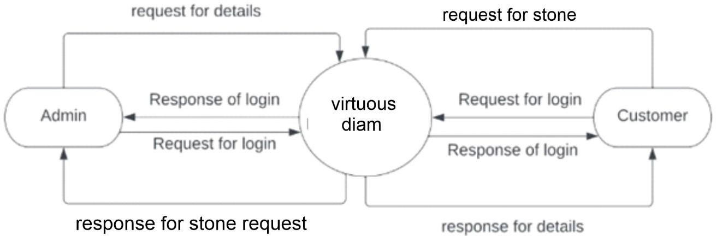



**1st Level Diagram:**

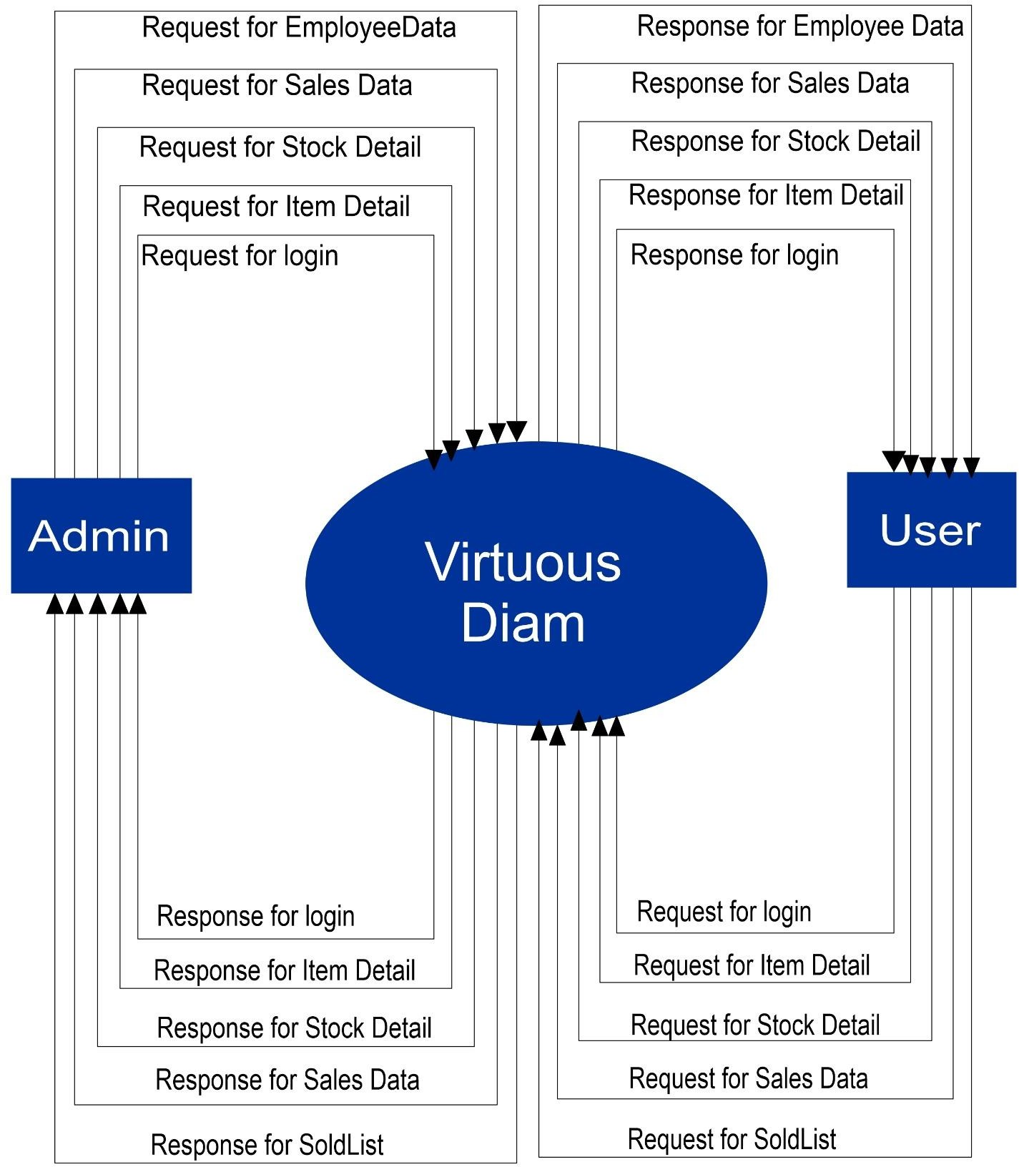



**2nd level request Diagram:**

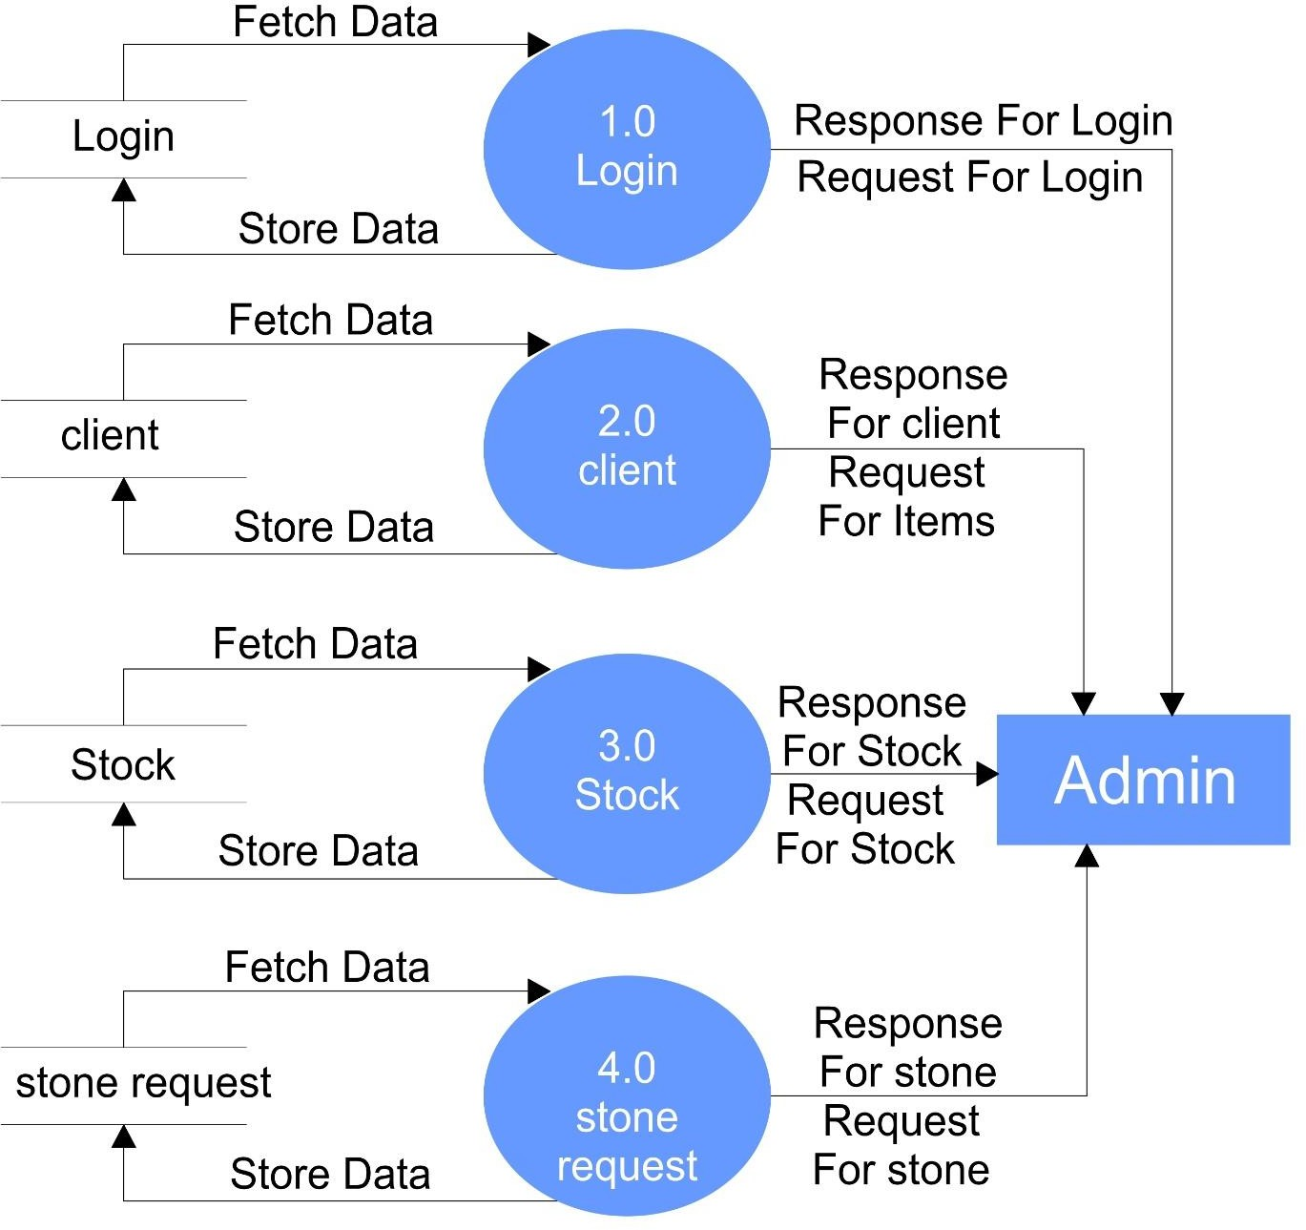



**UML diagram:**

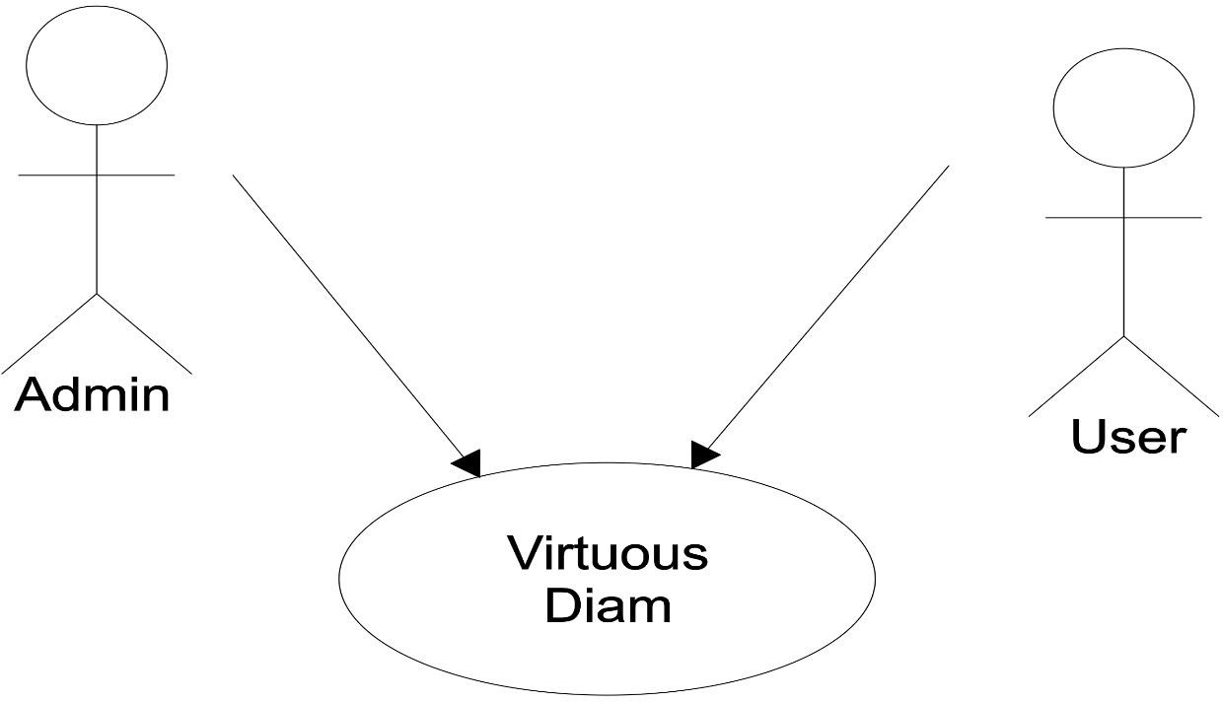

**Admin Side:**

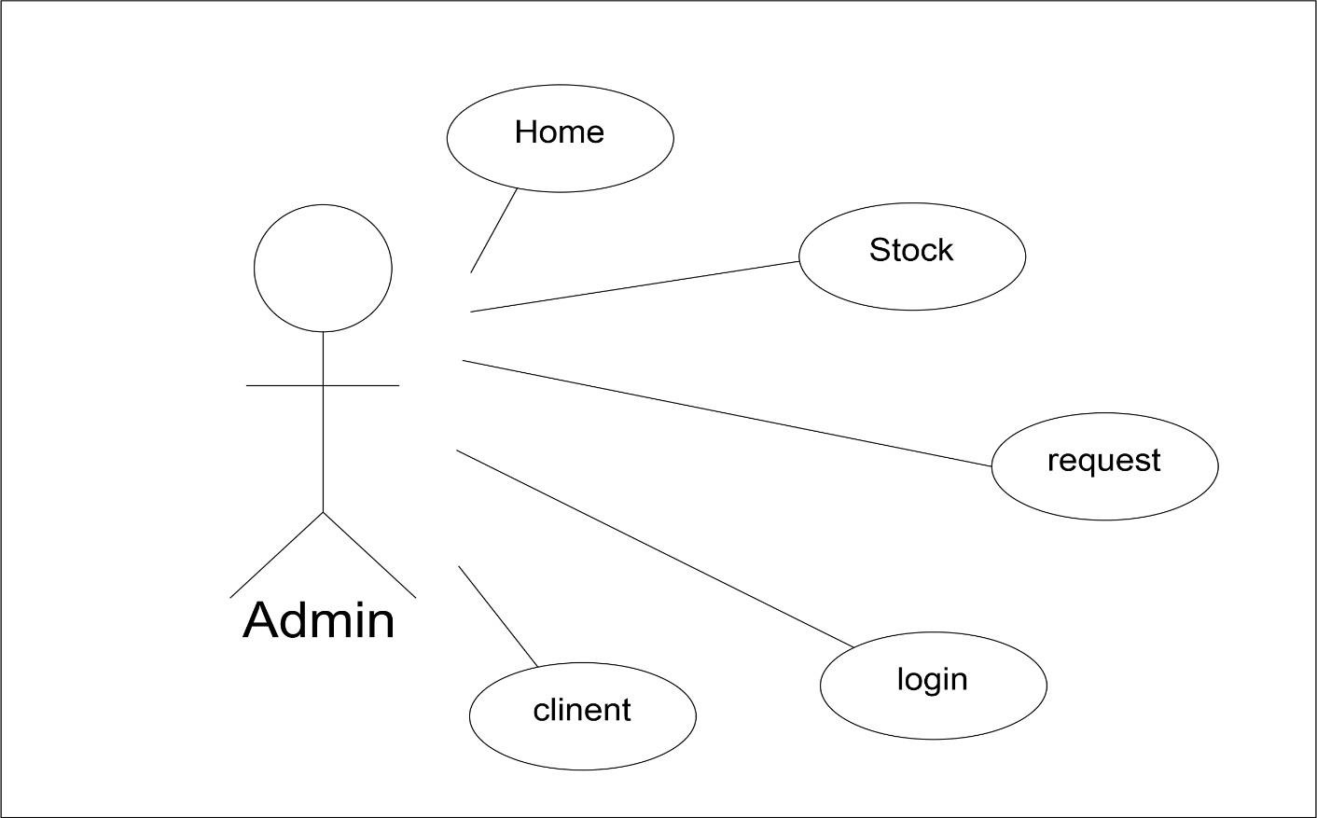



**User side:**

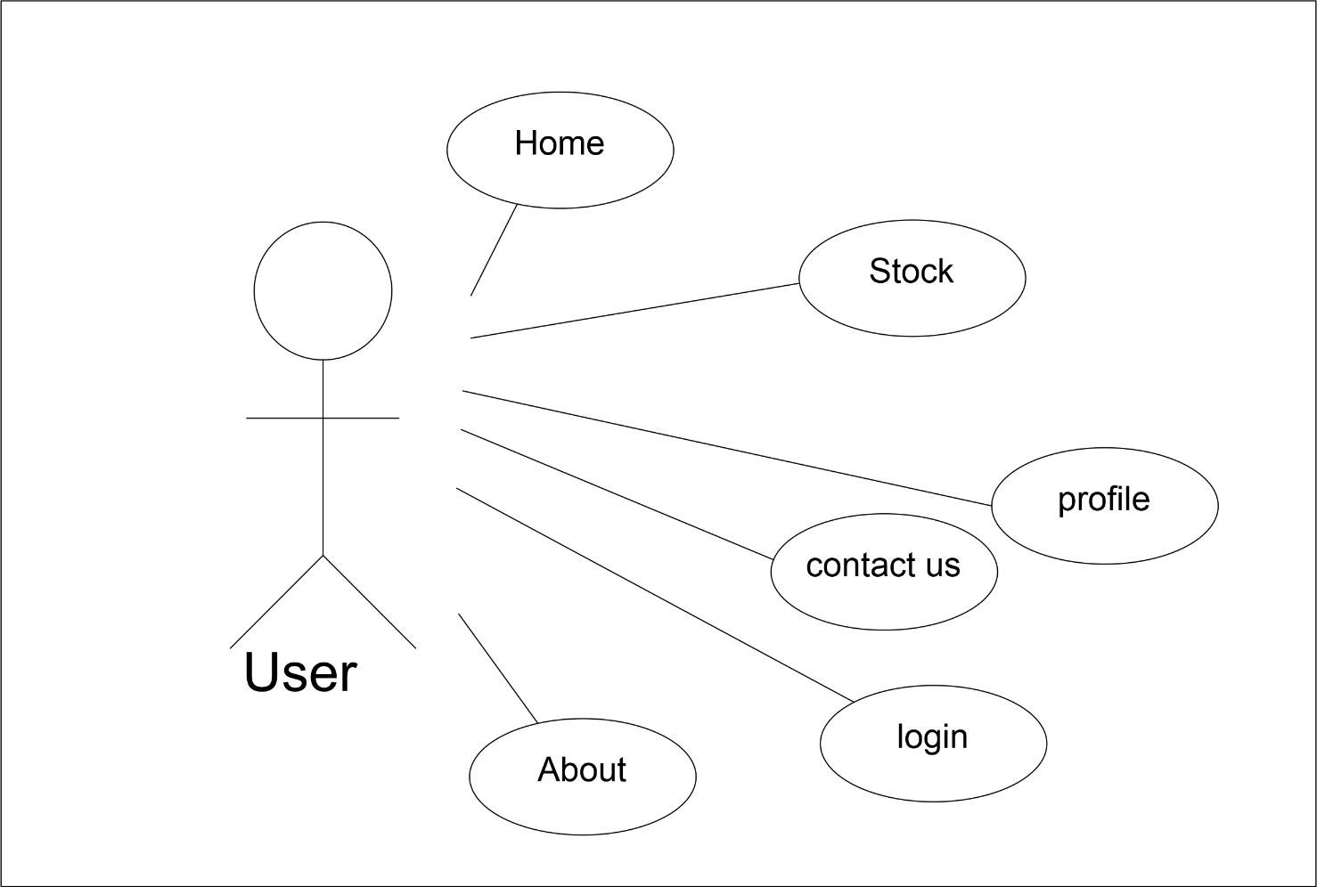



* 1. **Process Specification / Activity Flow Diagram**

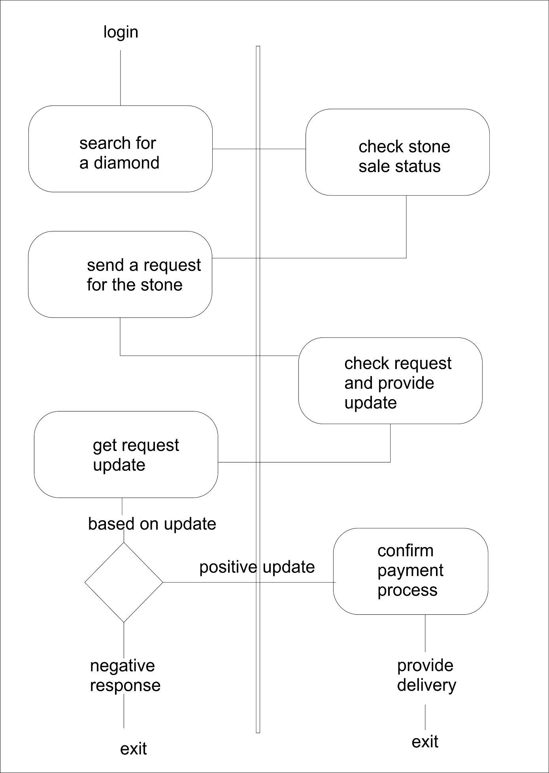



* 1. **Data Directories**

|  |  |
| --- | --- |
| USER | |
| Alias | Null |
| Where used/How used | To retrieve or store user details |
| Description | name + email + userid + password + confirm password |
| Supplementary information | Userid must be unique |

|  |  |
| --- | --- |
| ADMIN | |
| Alias | Null |
| Where used/How used | To retrieve or store admin details |
| Description | userid + password |

|  |  |
| --- | --- |
| Stock | |
| Alias | Null |
| Where used/How used | To retrieve or stock details |
| Description | Stockid + shape + availability + registration info |
| Supplementary information | Stockid must be unique |

|  |  |
| --- | --- |
| Request | |
| Alias | Null |
| Where used/How used | To retrieve request details |
| Description | Requested + username + stockid + request status |
| Supplementary information | Request id must be unique |



* 1. **Entity-Relationship Diagram / Class Diagram**

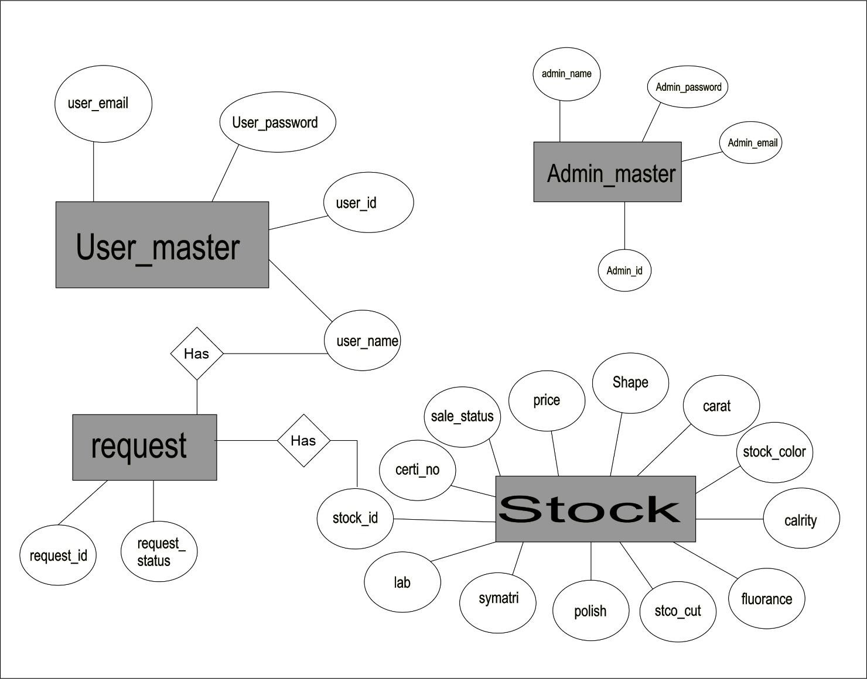



# System Design

* 1. **Database Design Table: admin_master**

**Description: This table gives detail about admin information**

|  |  |  |  |
| --- | --- | --- | --- |
| Field Name | Field Type | Constraint | Description |
| admin_id | int(11) | Primary key | admin id |
| admin_uname | varchar(20) | unique | admin username |
| admin_email | varchar(50) | Unique | admin email |
| password | varchar(100) | not null | admin password |

**Table: user_master**

**Description: This table gives detail about user information**

|  |  |  |  |
| --- | --- | --- | --- |
| Field Name | Field Type | Constraint | Description |
| user_id | int(11) | Primary key | User id |
| user_name | varchar(20) | Unique | username |
| user_email | varchar(50) | Unique | User email |
| Password | varchar(100) | not null | User password |

**Table: stock_master**

**Description: This table gives detail about stock information**

|  |  |  |  |
| --- | --- | --- | --- |
| Field Name | Field Type | Constraint | Description |
| Stock_id | int(11) | Primary key | Stock id |
| Shape | varchar(20) | Not null | Stone Shape |
| Carat | varchar(50) | Not null | stone weight |
| Stock_color | varchar(100) | not null | Stone |
| Clarity | varchar(20) | Not null | Stone clarity |
| Fluorance | varchar(20) | Not null | fluorance |
| Stock_cut | varchar(20) | Not null | Stone cut |
| Polish | varchar(20) | Not null | Stone polish |
| Symatri | varchar(20) | Not null | symatri |
| Lab | varchar(20) | Not null | Registration lab |
| Certi_no | varchar(50) | Unique | Registration no |
| Price | Int(100) |  | Price per carat |
| Sale_status | varchar(20) | Not null | Default(unsold) |

**Table: user_request_master**

**Description: This table gives detail about user requested stones information**

|  |  |  |  |
| --- | --- | --- | --- |
| Field Name | Field Type | Constraint | Description |
| Request_id | int(11) | Primary key | Request id |
| User_name | varchar(20) | Not null | Username |
| Stock id | varchar(50) | Not null | Stock id |
| Request  status | varchar(100) | not null | Request  progress status |



* 1. **Directory structure**
     + Admin:
       - admin_home.php
       - stock.php
       - login.php
       - request.php
       - ​
     + User
       - about.php
       - contact.php
       - index.php
       - login.php
       - stock.php
       - profile.php
       - register.php



* 1. **Input Design**

Admin & User Log In:

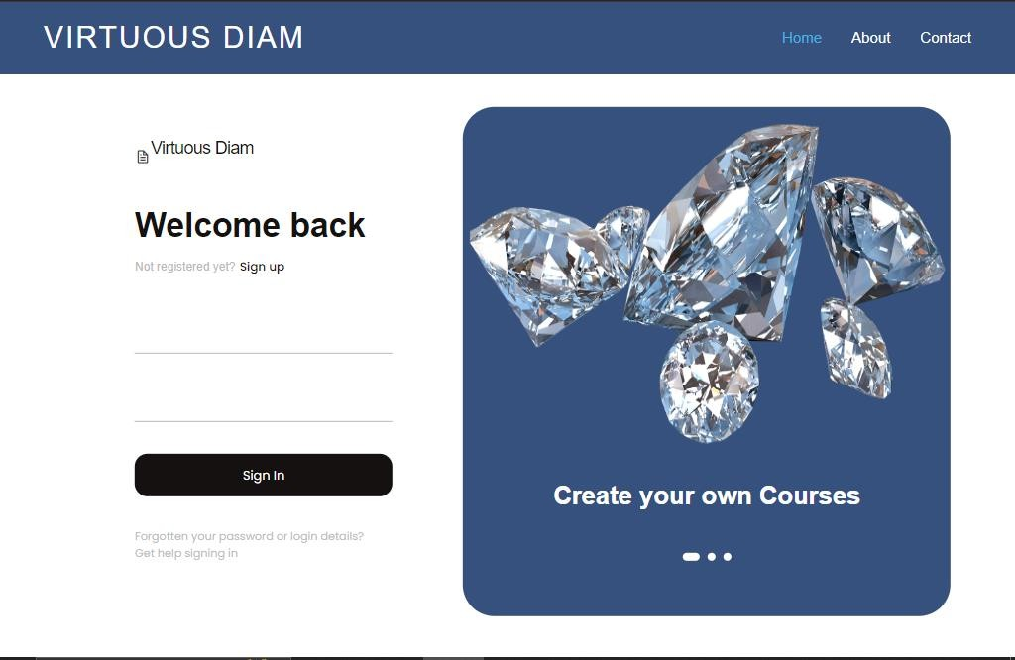

User Registration:

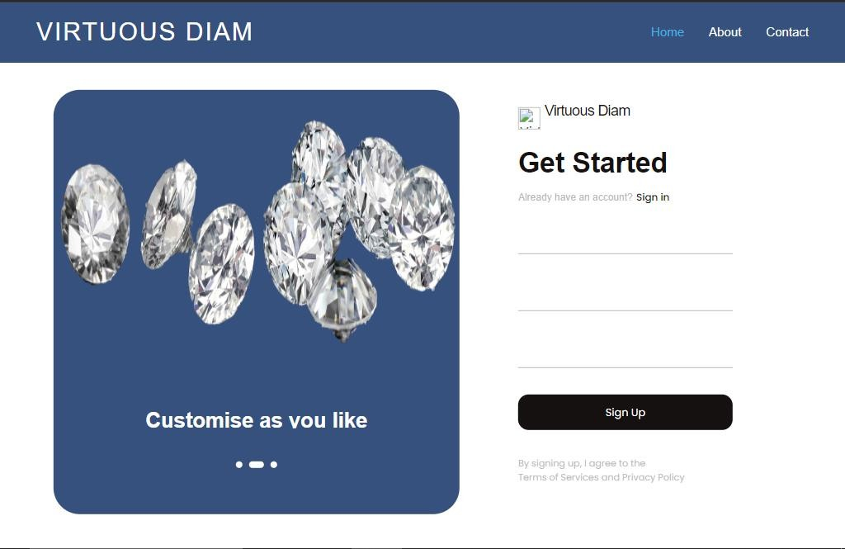



Stock Operaions:

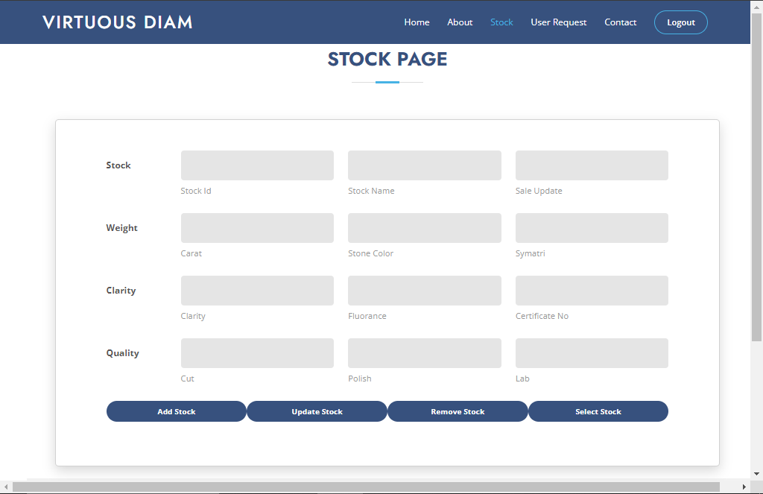

Request Operaions & display:

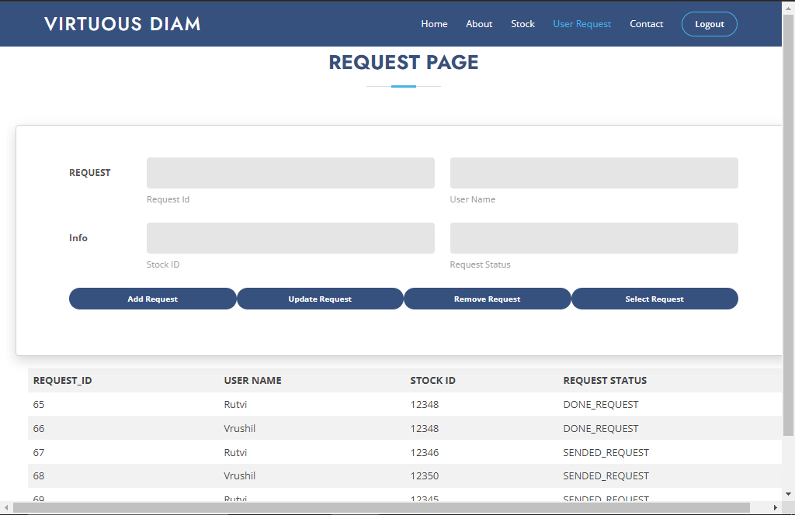



Request Stock:

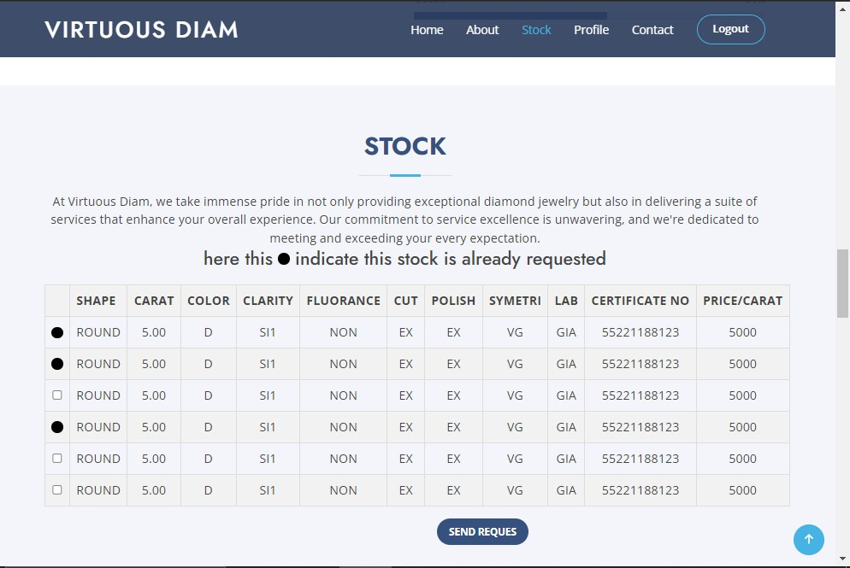

Profile Request Update:

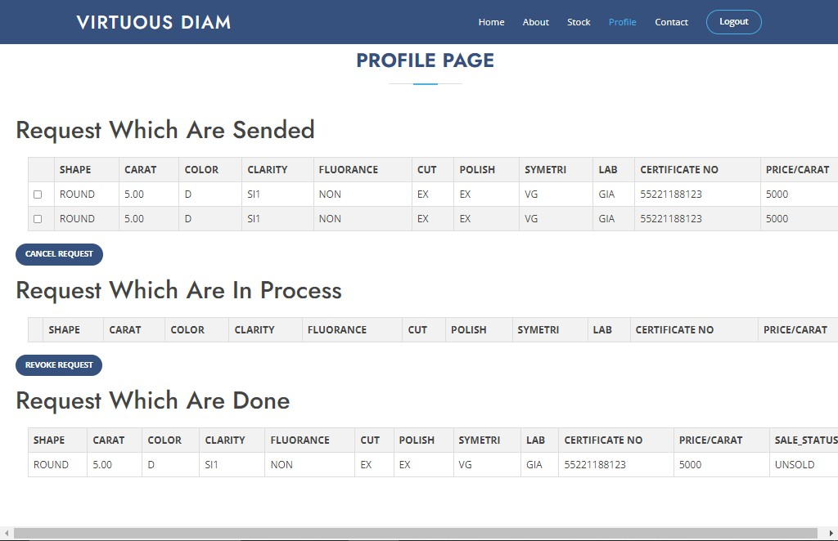



* 1. **Output Design:**

Home Page:

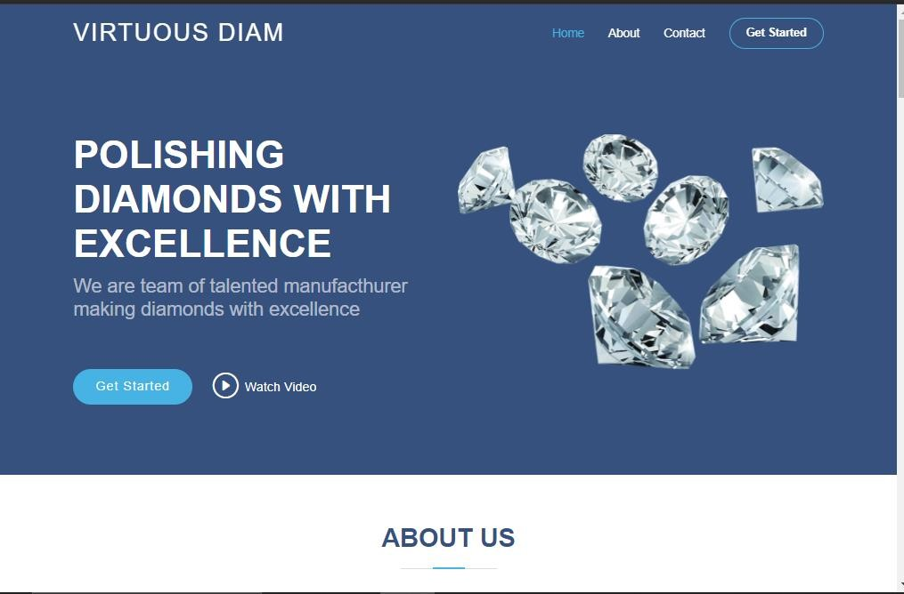

Contact Us:

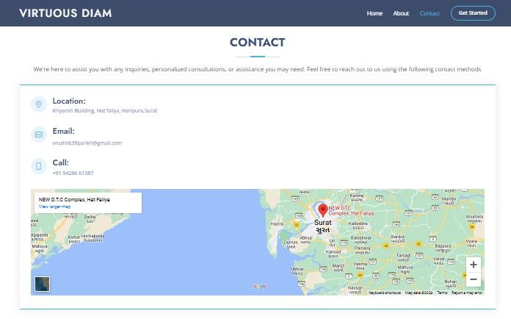



About Page:

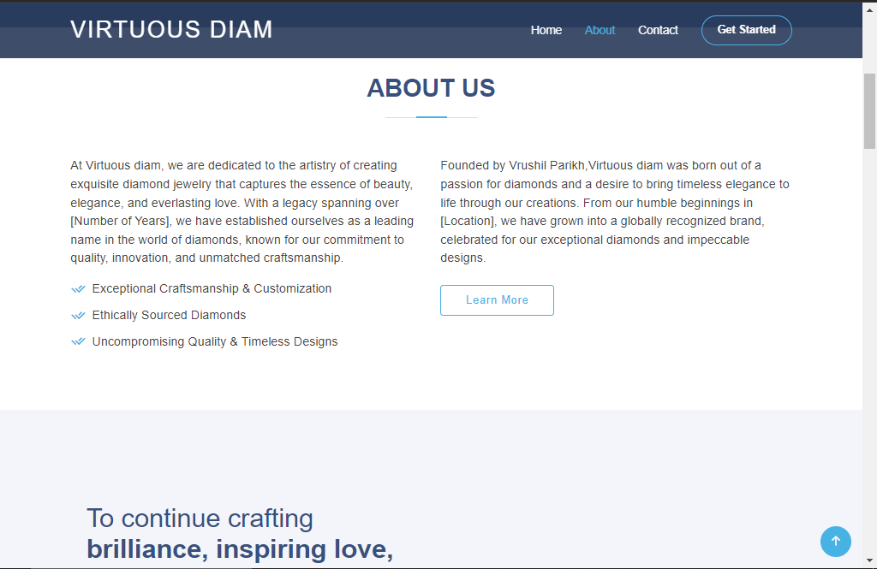

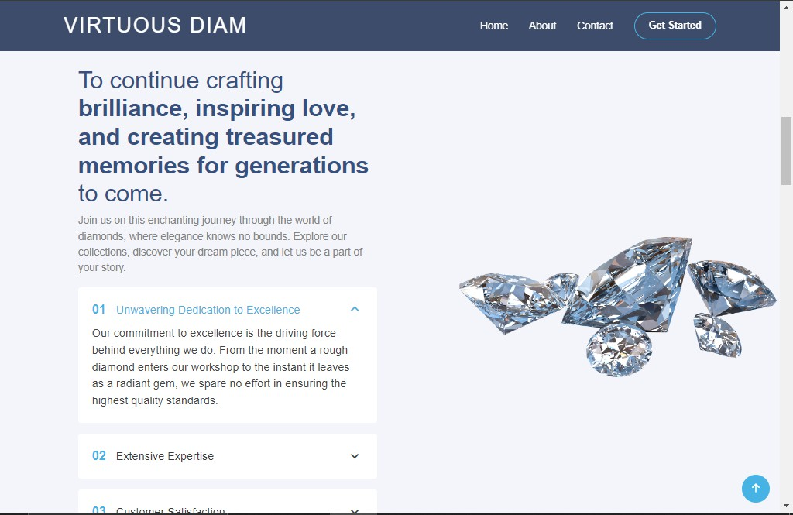



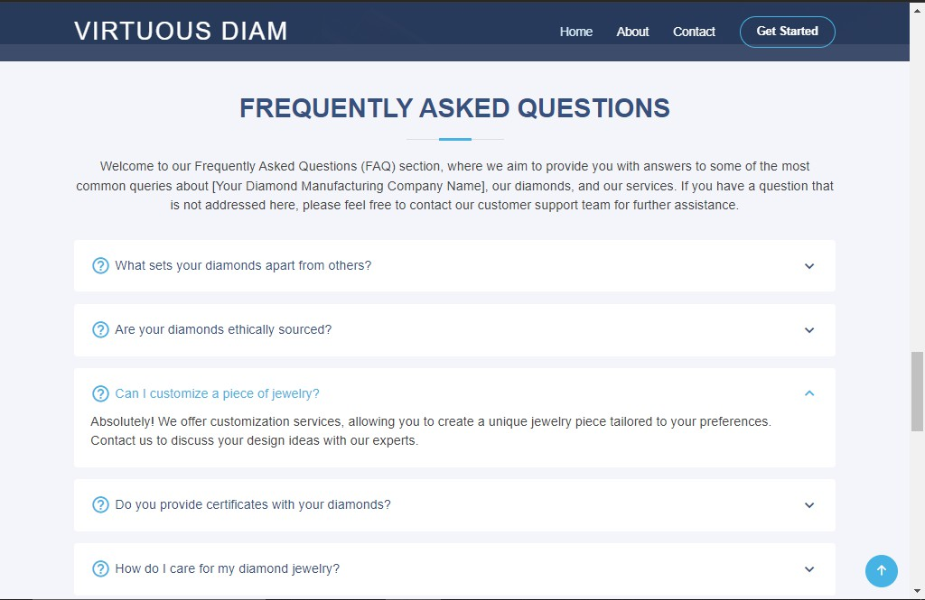



# Software Testing

The testing process focuses on the logical intervals of the software ensuring that all statements have been tested and on functional interval is conducting tests to uncover errors and ensure that defined input will produce actual results that agree with the required results. Program level testing, modules level testing integrated and carried out.

Functional Testing:

* All web page is working properly.
* All navigation work properly.
* MySQL database work Proper.
* All Pages Design is perfect.

Environment Testing :

* Internet explorer and chrome consider testing for environment
* operability of software.
* Web server - IIS/Apache
* Database – SQL Server Management Studio
* OS – Windows 11
* Browser – Internet Explorer/Chrome



# Limitations and Future Scope of Enhancements

**Limitations**:

Although I have put my best efforts to make the software flexible, easy to operate but limitations cannot be ruled out even by me. Though the software presents a broad range of options to its users some intricate options could not be covered into it; partly because of logistic and partly due to lack of sophistication. Paucity of time was also major constraint, thus it was not possible to make the software foolproof and dynamic.

Lack of time also compelled me to ignore some part such as storing old result of the candidate etc.

**Scope:**

The future scope includes expand the technologies like HTML and PHP we can also add new technologies like Laravel, reactjs many more for improving the efficiency of the software.

The Online Flight Booking system is the next generation address book which will provide these two basic services like portability, security.

The project will be useful for any schools and colleges with slightly modification. Project is flexible ie. any change /modification in database may be performing easily.

* This project can be upgraded by adding more options such as Ticket editing and more admin operations.
* Payment options and document checking such as ID proofs can be added.
* Applications can be upgraded by improving performance as per user feedback.



# References

https://[www.w3schools.com/php/php_sessions.asp](http://www.w3schools.com/php/php_sessions.asp) https://[www.w3schools.com/Php/php_mysql_connect.asp](http://www.w3schools.com/Php/php_mysql_connect.asp) https://[www.tutorialspoint.com/javascript/javascript_regexp_object.htm](http://www.tutorialspoint.com/javascript/javascript_regexp_object.htm) https://[www.tutorialspoint.com/javascript/javascript_animation.htm](http://www.tutorialspoint.com/javascript/javascript_animation.htm) https://[www.codewithharry.com/videos/learn-php-in-one-video-in-hindi-2020/](http://www.codewithharry.com/videos/learn-php-in-one-video-in-hindi-2020/)